Name – Soniya Nagargoje

Email- <Soniyanagargoje8689@gmail.com>

Batch Date- 01-Jan-2023

Course Name- SQL

**Database- Pelican store**

**Q1: Which gender gives the maximum sales?**

Ans- Select sum (sales) from Pelicanstore where gender = “Male”; > 395.4

Select sum (sales) from pelicanstore where gender = “Female” ; which shows 7364.65

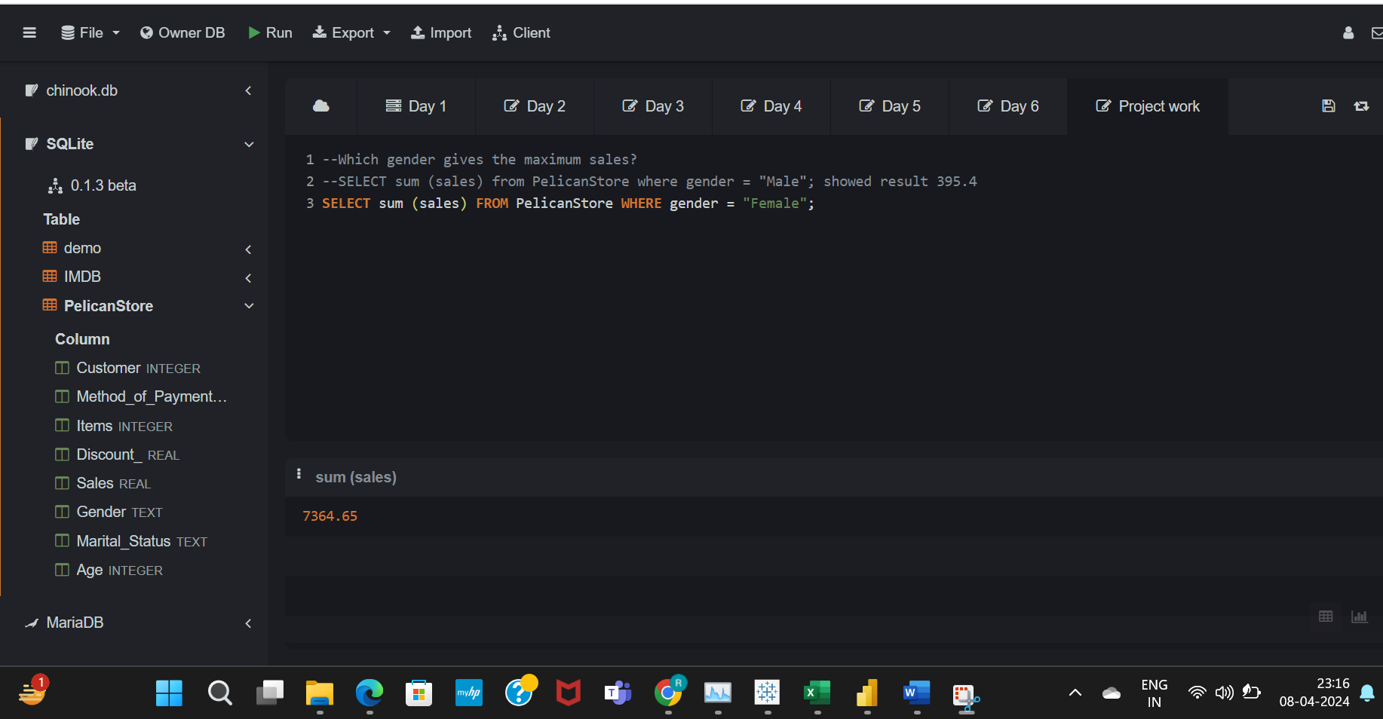

**Q2. Which age group and gender gives the maximum sales? –**

Ans- Females and 30-50 age group gives the maximum sales.

Select Age, Gender, Sales from store order by cast (Sales as float) desc limit 5;

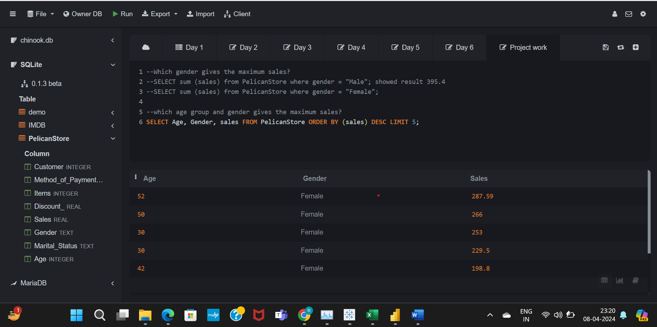

**Q3. What is the highest discount given to females?**

Ans- select * from store where gender = "Female" order by discount desc;

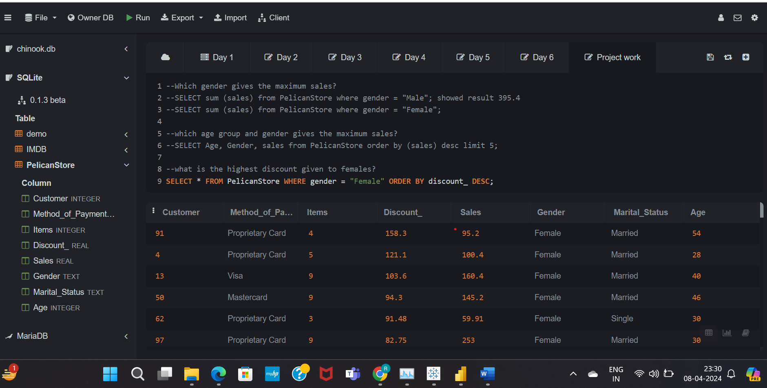

**Q4. What is the average discount given to females in the store?**

Ans - Select avg(discount) from store where gender = "Female";

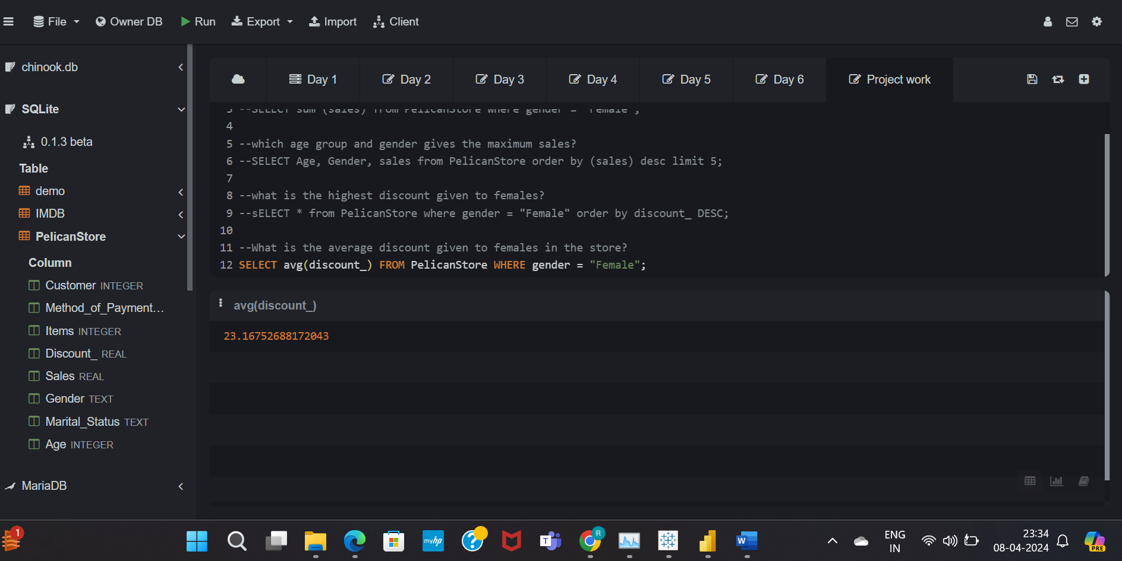

**Database – Baseball_ball data.csv**

**Q4. Who are the Top 5 players having height more than average?**

Average height – 80

Code: select * from sport;

Select avg(height) from sport; Select name, height from sport where height > (Select cast (avg(height) as float) from sport) order by height desc limit 5;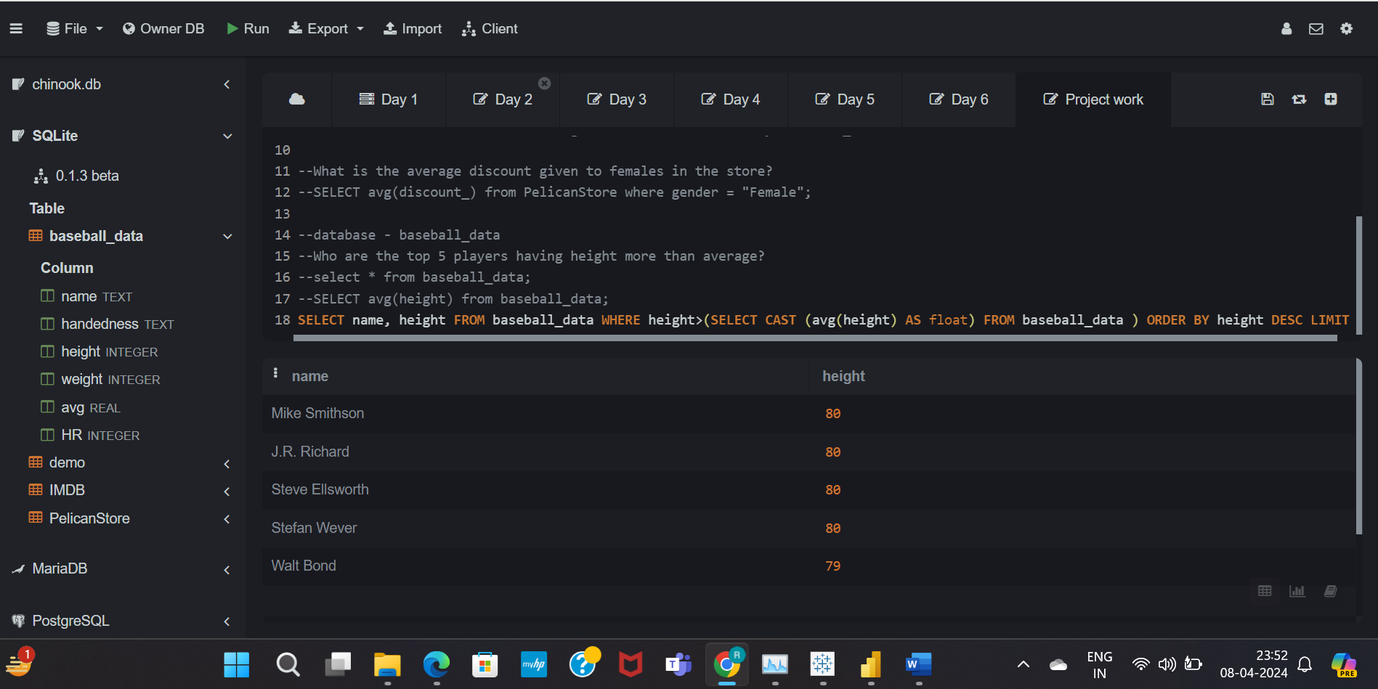

**Q5. Botton 2 players having least weight and must be left handed?**

Ans- select * from sport where handedness = "L" order by weight;

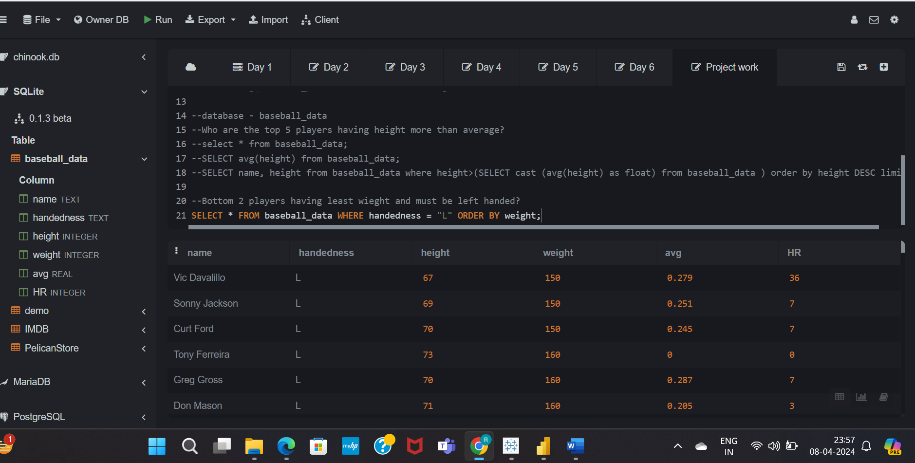

**Database – Chinook.db**

**Q6. Top 2 invoices of Germany customers with names and Do the sum of the invoices of Germany customers.**

Ans- select total_invoices, country, firstname from invoices inner join customers on invoices.CustomerId = customers.customerid where country = "Germany" order by total_invoices DESC;

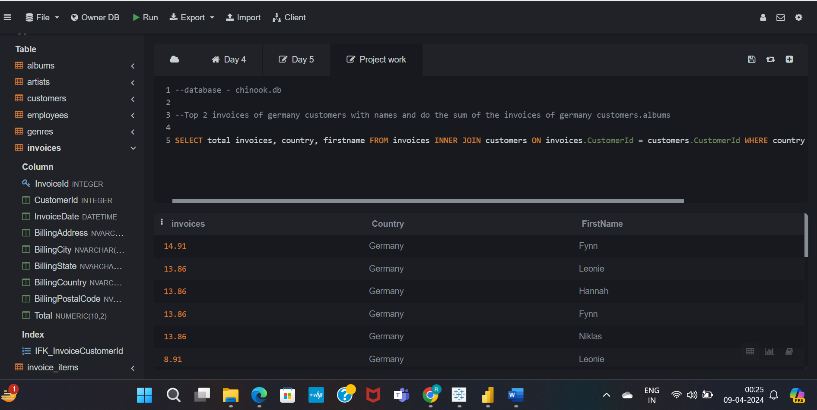

**Q8. Name the customer have the track id 232?**

Ans- select firstname, trackid from invoice_items a left outer join invoices b on b.InvoiceId = a.InvoiceId left OUTER JOIN customers c on c.CustomerId = b.CustomerId where trackid = "232";

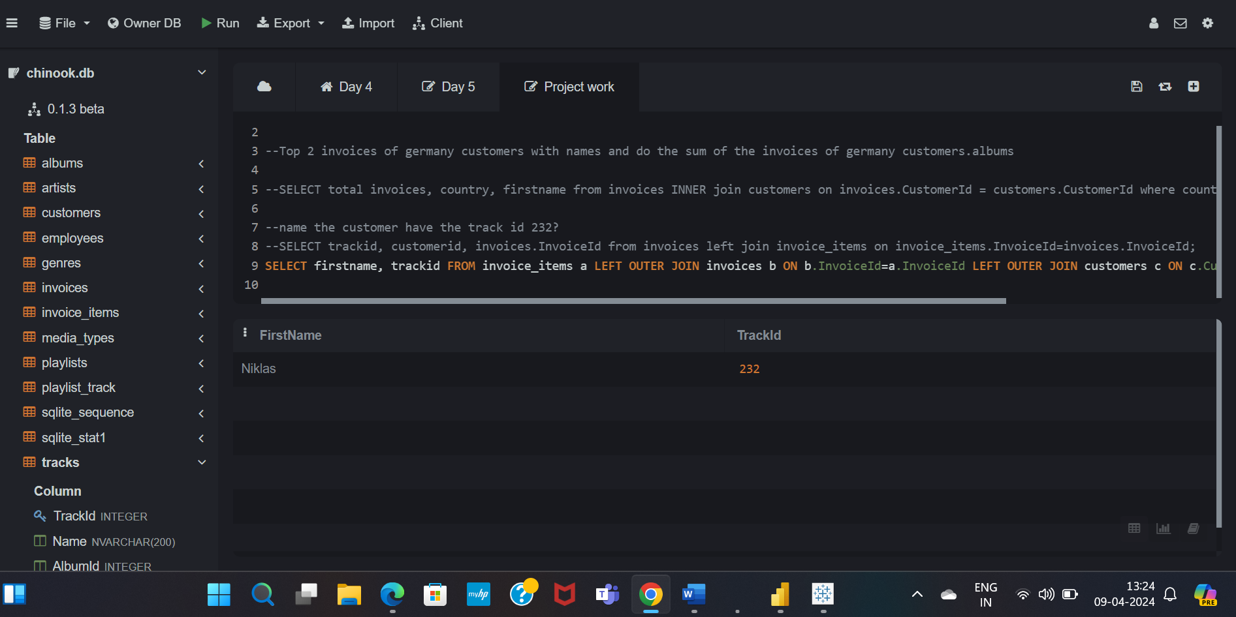

**Advance query:**

1. **Write query to return the email, first name, last name, & Genre of all Rock Music listeners. Return your list ordered alphabetically by email starting with A.?**

Ans- SELECT DISTINCT email, firstname, lastname from customers join invoices on customers.CustomerId=invoices.CustomerId

JOIN invoice_items on invoices.InvoiceId=invoice_items.InvoiceId

where trackid in (SELECT trackid from tracks join genres on tracks.GenreId=genres.GenreId

WHERE genres.Name like "rock") order by email;

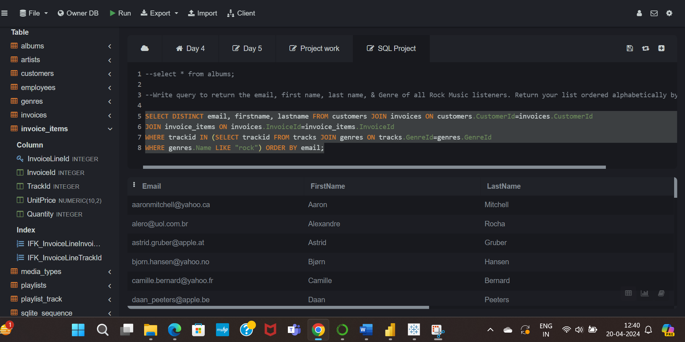

2. **Let's invite the artists who have written the most rock music in our dataset. Write a query that returns the Artist name and total track count of the top 10 rock bands?**

**Ans-** --SELECT * from tracks;

SELECT artists.ArtistId, artists.Name, COUNT (artists.ArtistId) as number_of_songs

from tracks join albums on albums.AlbumId= tracks.AlbumId

join artists on artists.ArtistId=albums.ArtistId

join genres on genres.GenreId=tracks.GenreId where genres.Name LIKE "Rock"

GROUP by artists.ArtistId order by number_of_songs DESC limit 10;

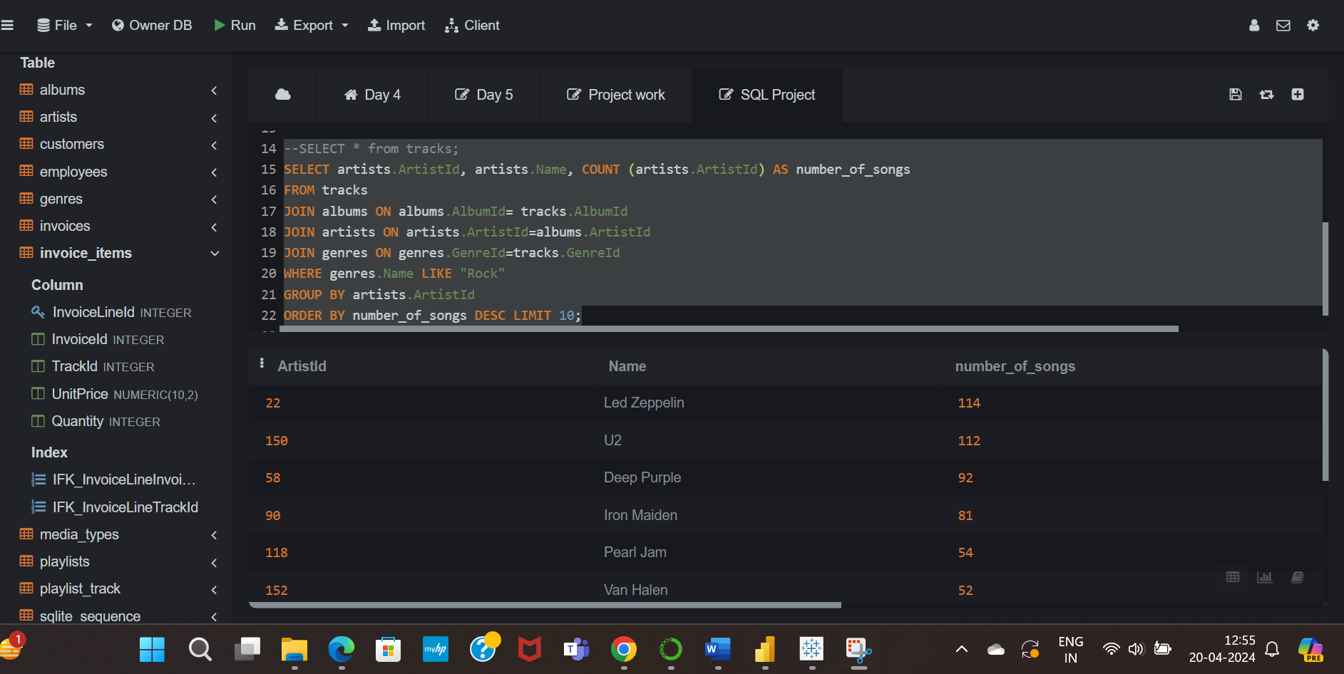

**3. Return all the track names that have a song length longer than the average song length. Return the Name and Milliseconds for each track. Order by the song length with the longest songs listed first?**

**Ans-** SELECT name, milliseconds from tracks where milliseconds >

(SELECT avg(milliseconds) as avg_track_length from tracks) order by milliseconds desc;

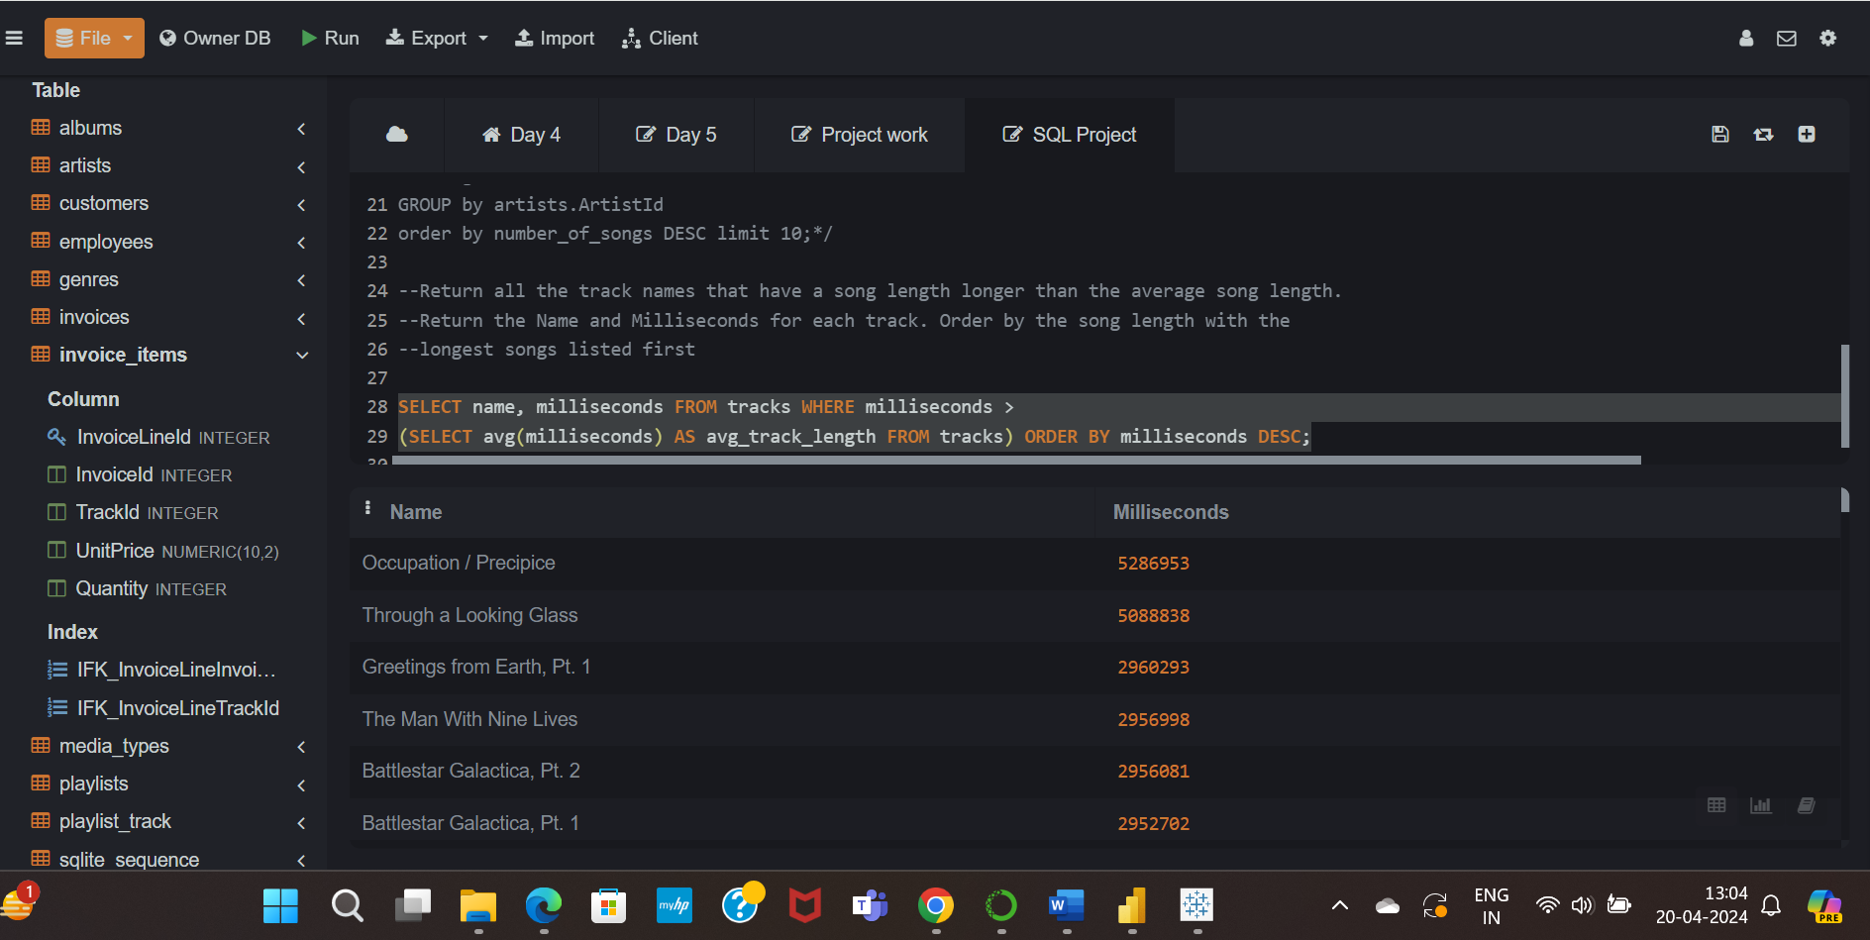

**Dataset - imdb**

**Q9. top 5 directors having rating more then average?**

Ans- Select director, actors, rating from imdb where rating > (SELECT avg(rating) from imdb) order by rating limit "5";

